Project: OSA_Alice

Date Created: 8/17/2022

Goal: To use past experience to build an ergonomic keyboard to extend my skills in Solidworks and engineering.

About the Project: The OSA Alice keyboard uses the OSA Alice PCB from The Key.Company along with Gateron Black Ink v2 switches. Using experience from the DZRGB60 v2 keyboard, I was able to measure out and build the casing for the PCB along with the plate in Solidworks. Though making the keyboard has a similar process to the DZRGB60 v2, I ran into different obstacles when building the OSA Alice keyboard.

Images:

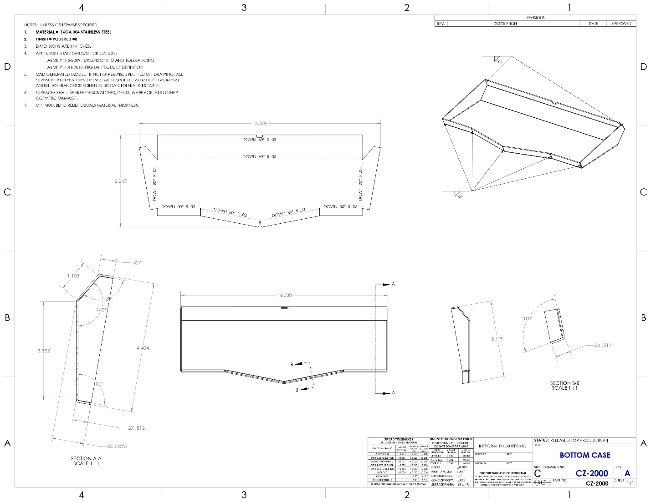

***Figure 1.*** Solidworks drawing for CZ-2000 (Bottom Case).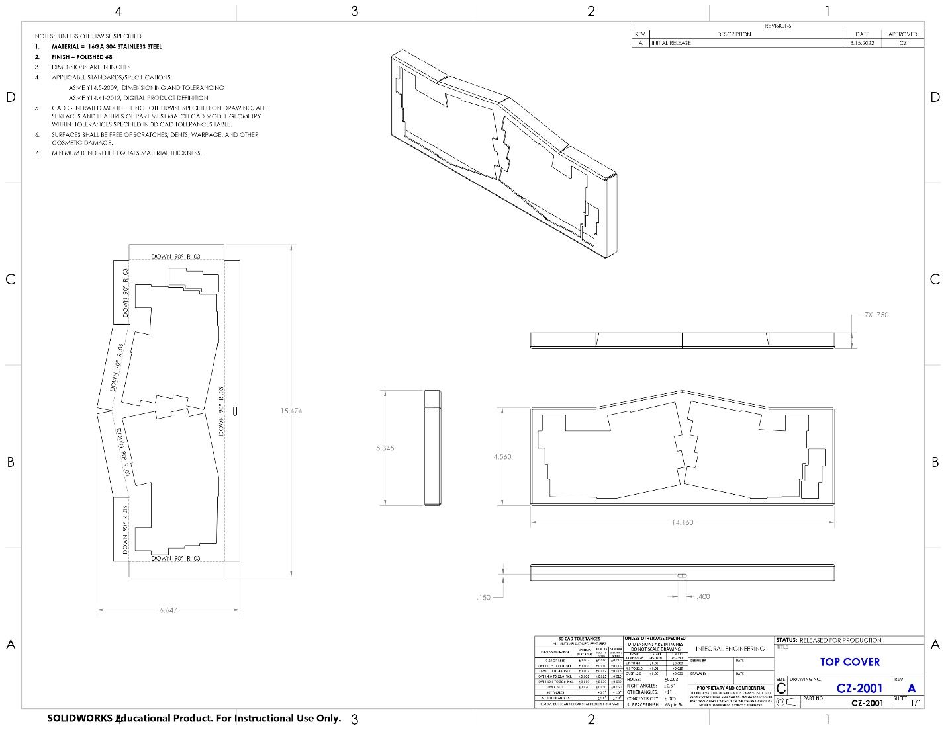

***Figure 2.*** 2D CAD drawing for CZ-2001 (Top Cover).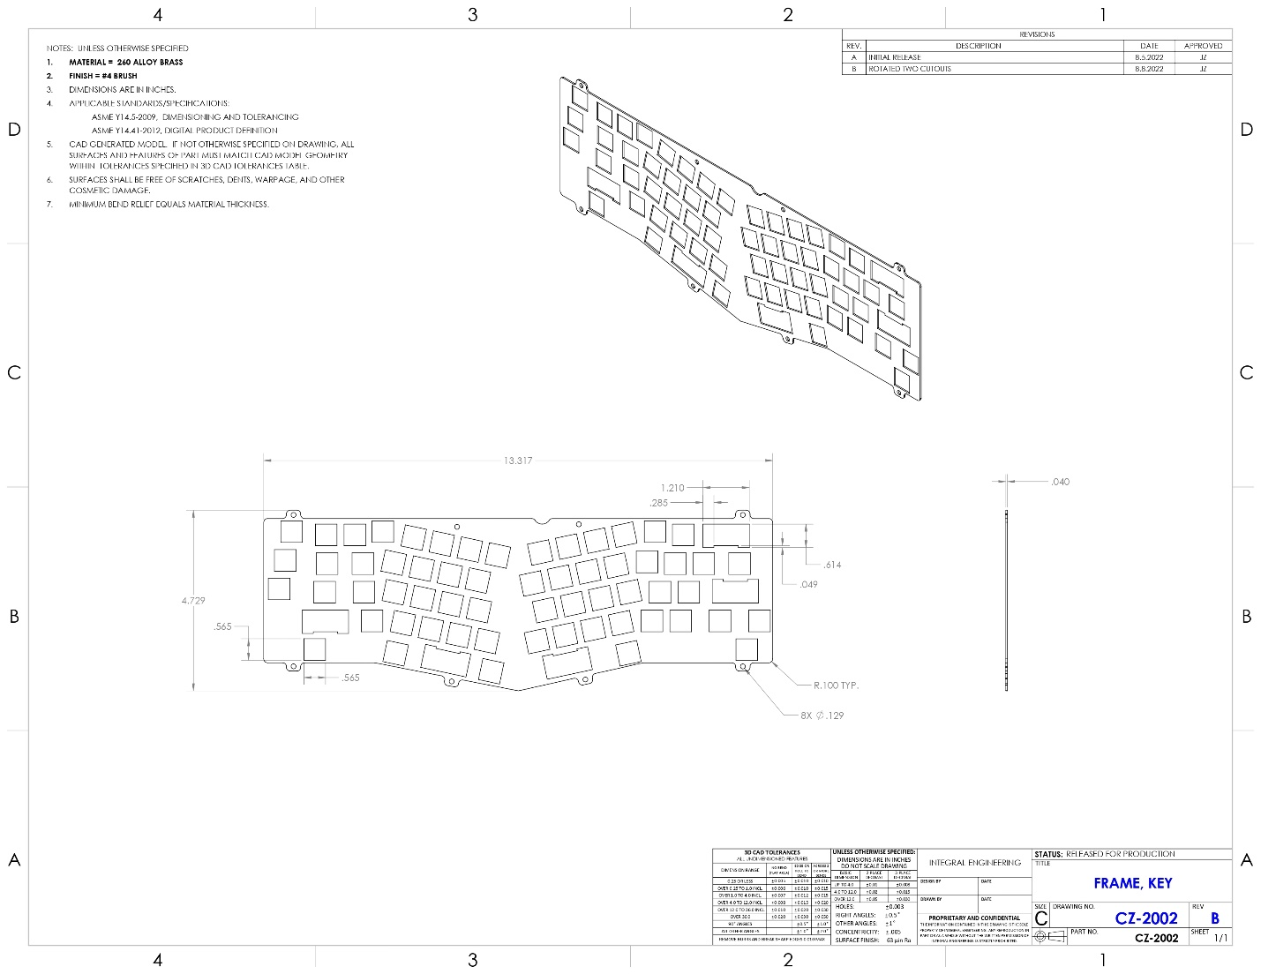

***Figure 3.*** 2D CAD drawing for CZ-2002 (Plate).

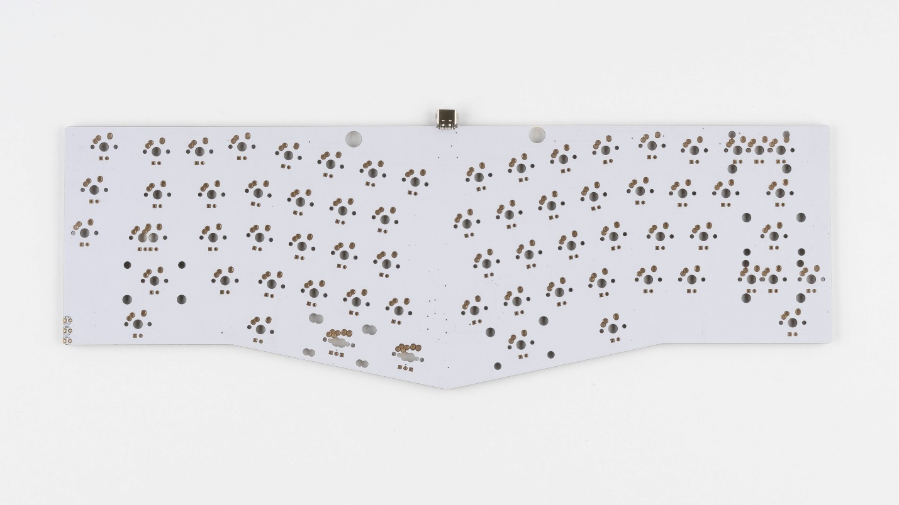

***Figure 4.*** OSA Alice PCB from The Key.Company.

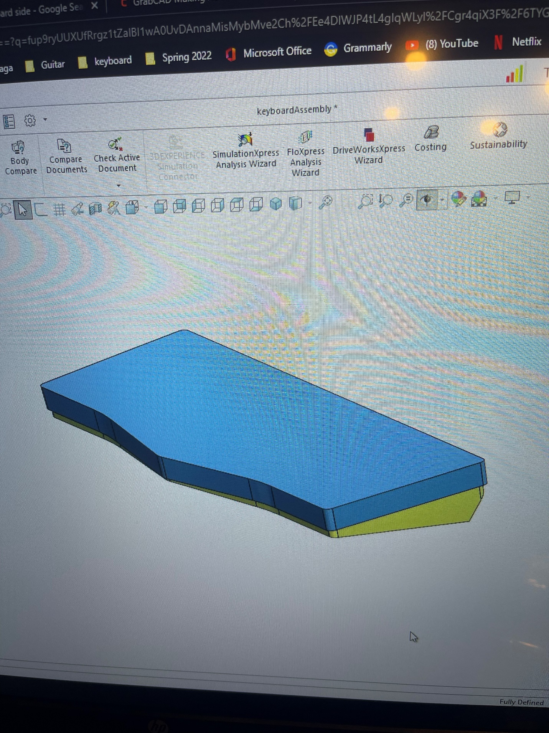

***Figure 5.*** Solidworks programming for designing keyboard case.

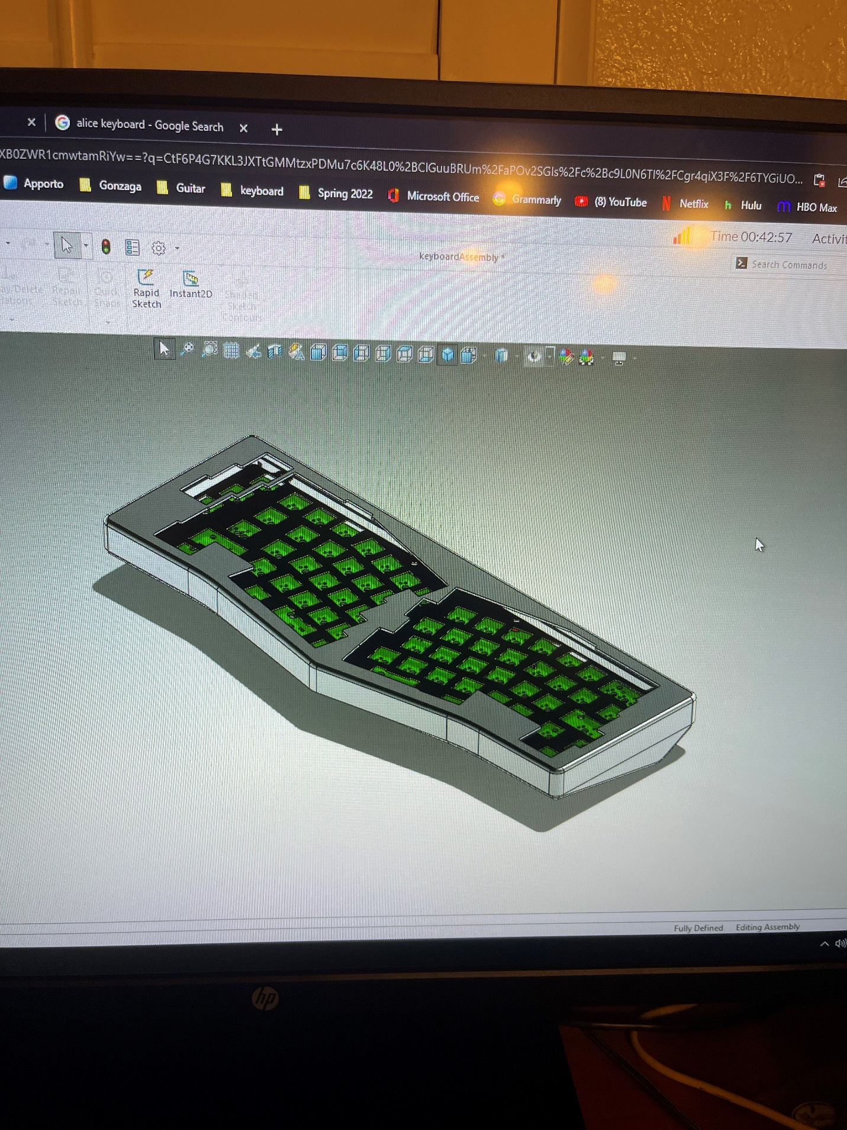

***Figure 6.*** Solidworks programming for designing keyboard.

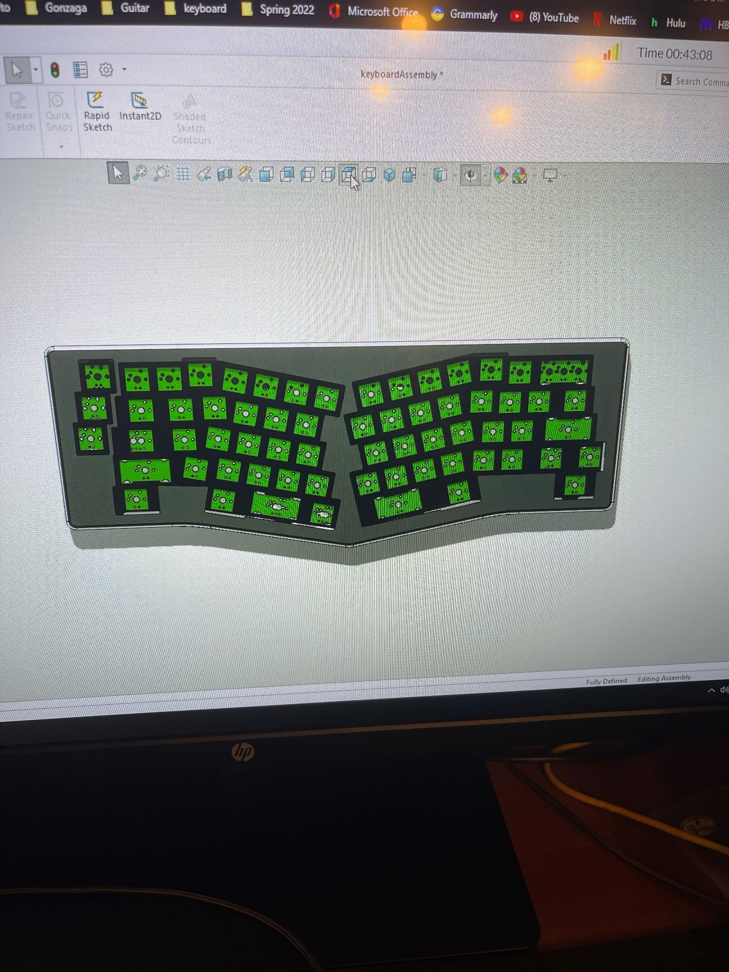 ***Figure 7.*** Solidworks programming for designing keyboard.

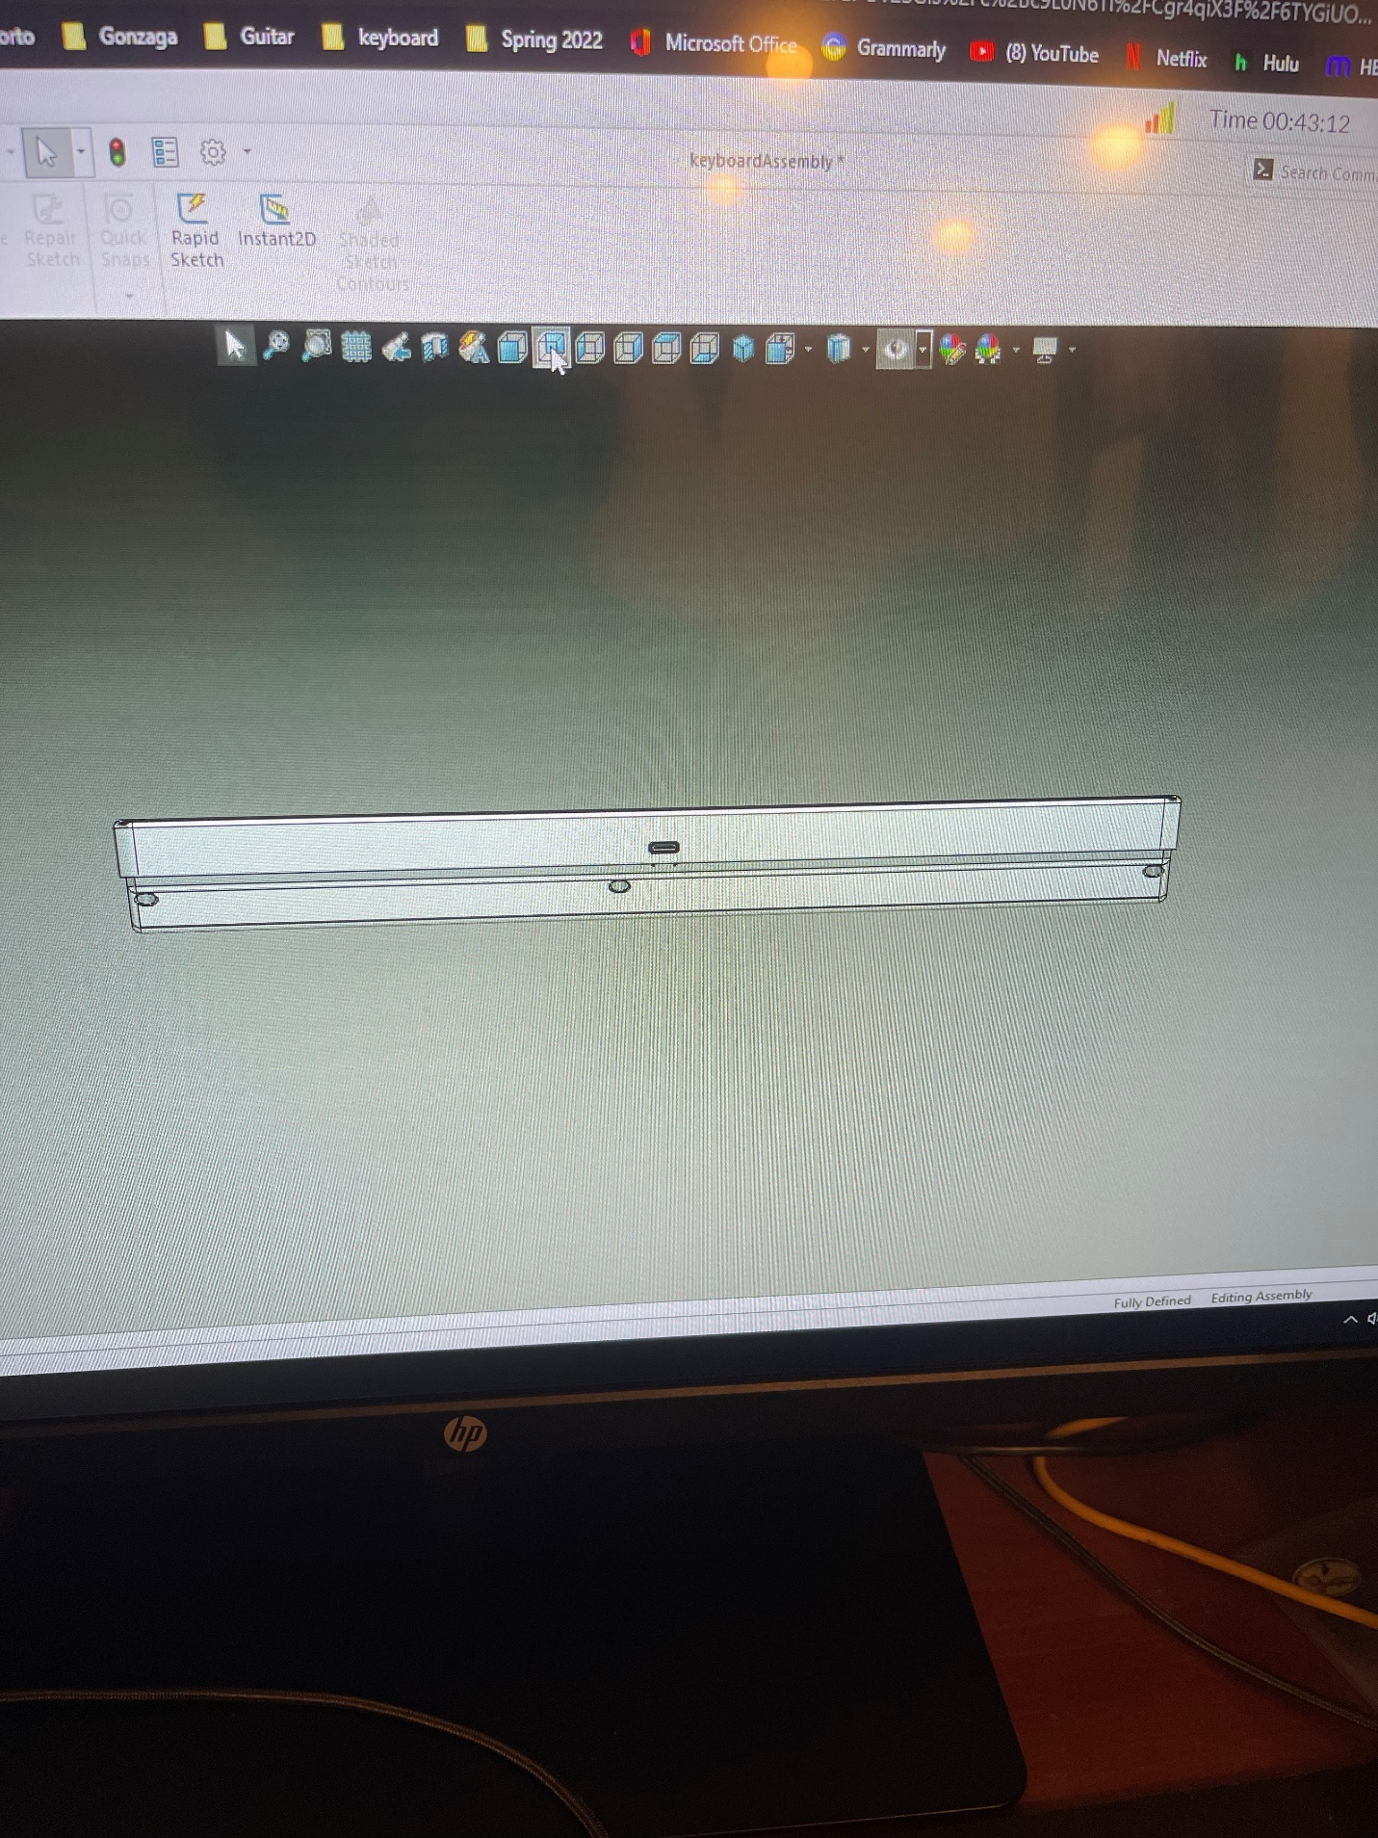

***Figure 8.*** Solidworks programming for designing keyboard.7

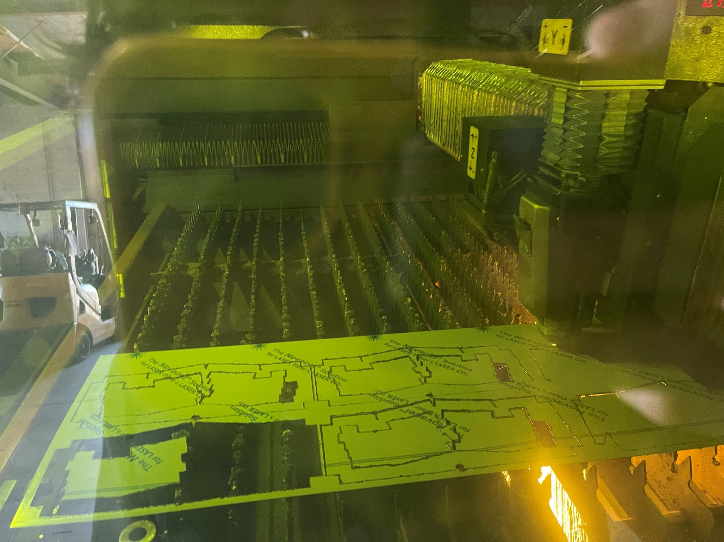

***Figure 9.*** Laser machine cutting out CZ-2001 (see *Figure 2.)*.

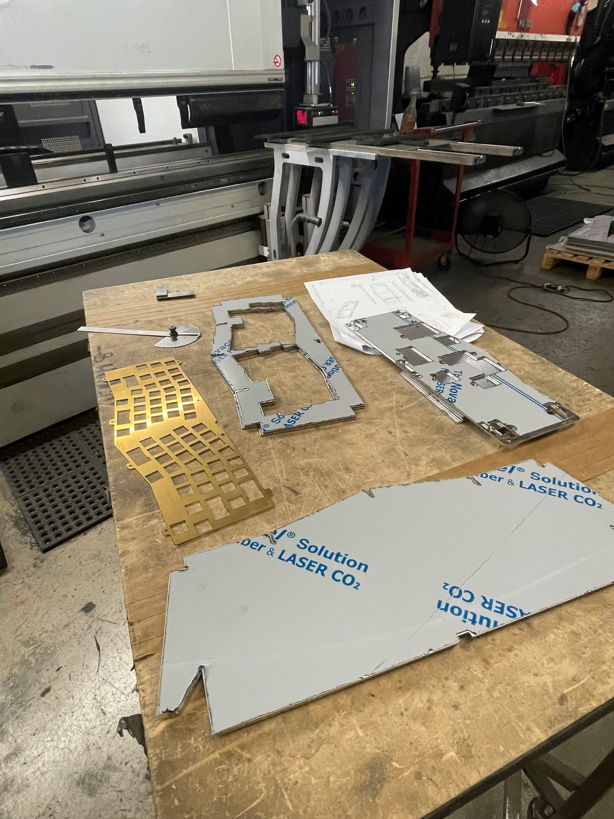

***Figure 10.*** CZ-2000, CZ-2001, and CZ2002 laser cut using machine.

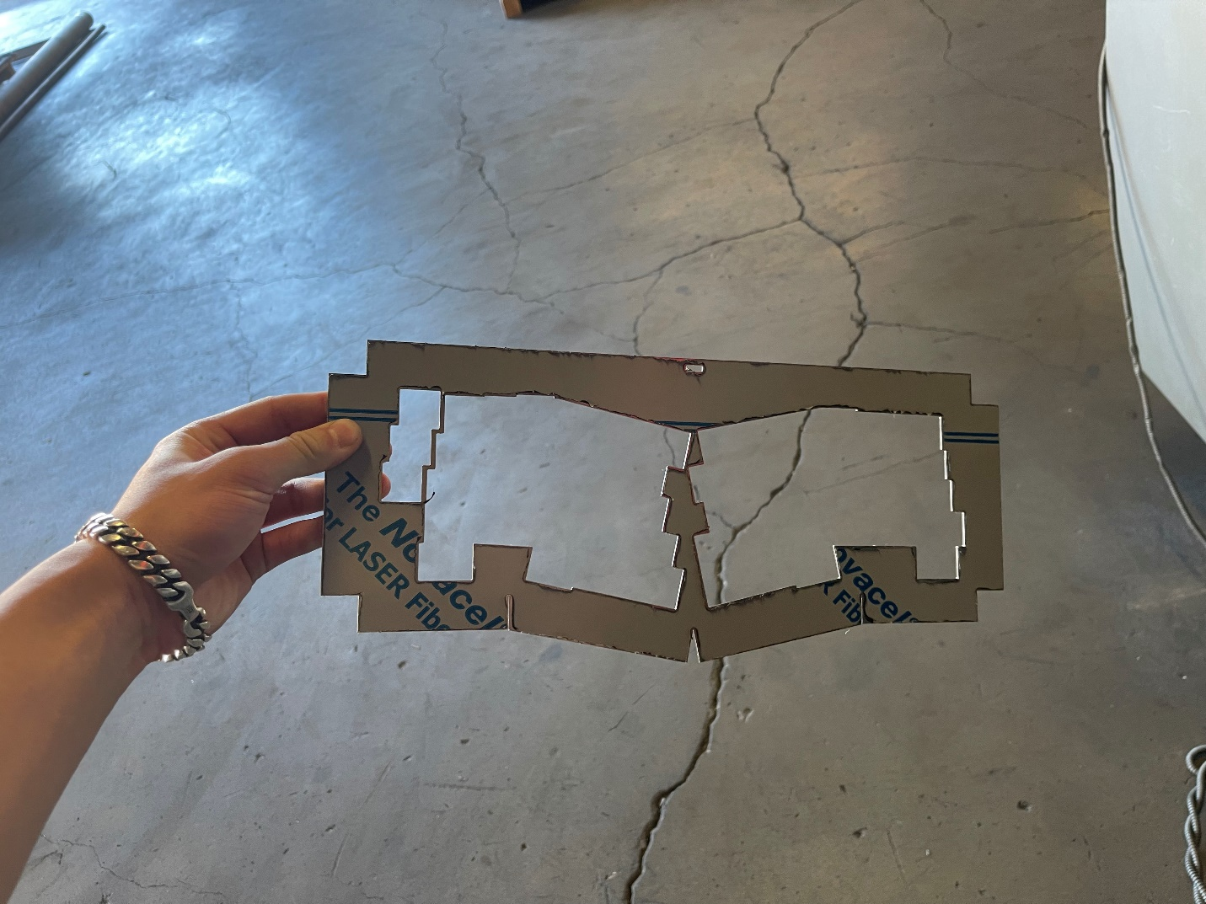

***Figure 11.*** CZ-2001 physical part (see *Figure 2.* and *Figure 9.)*.

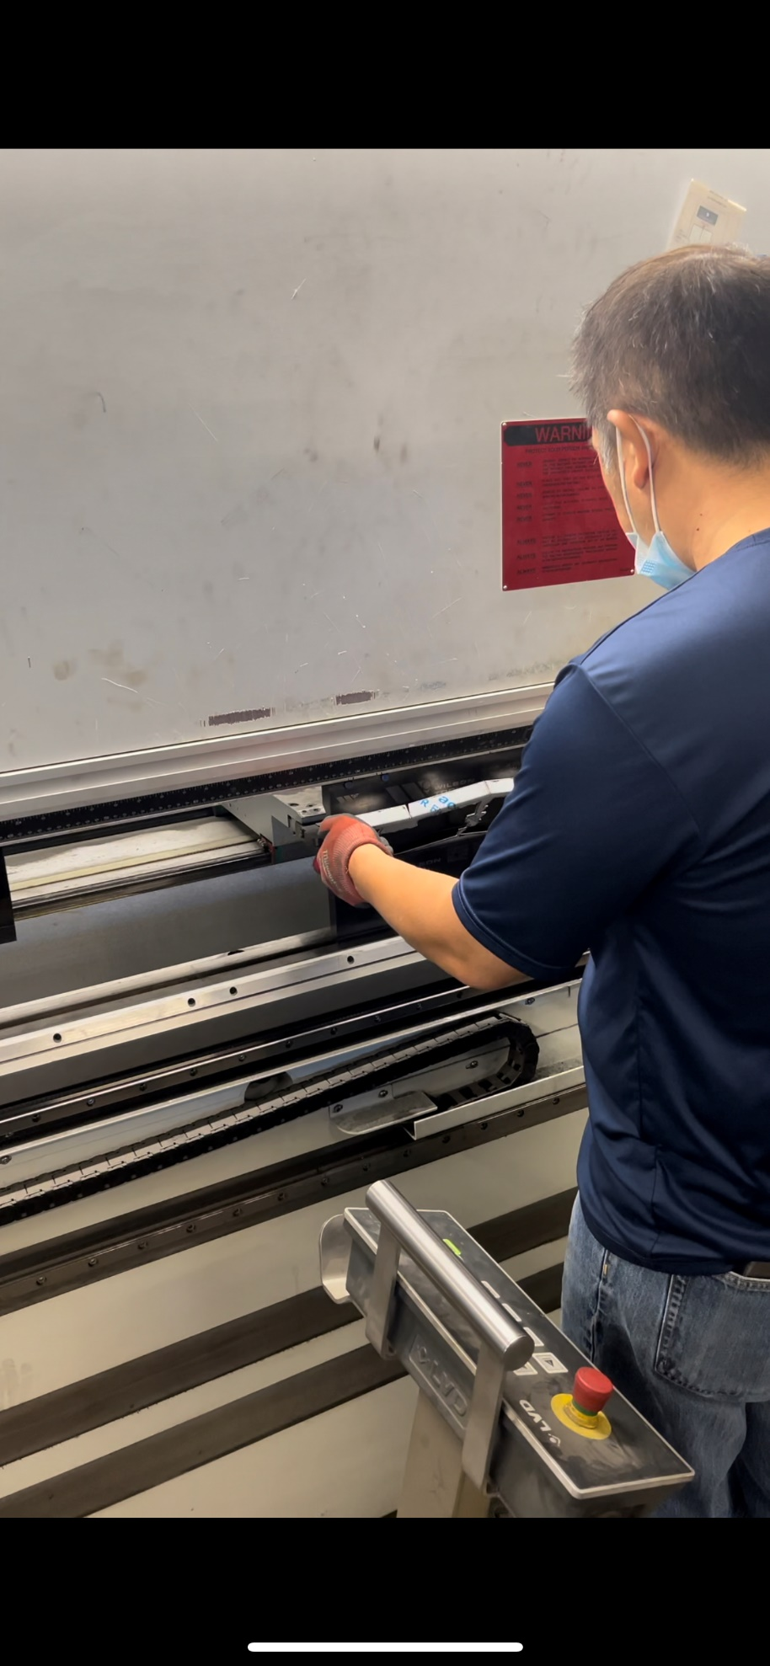

***Figure 12.*** Bending process of the keyboard case

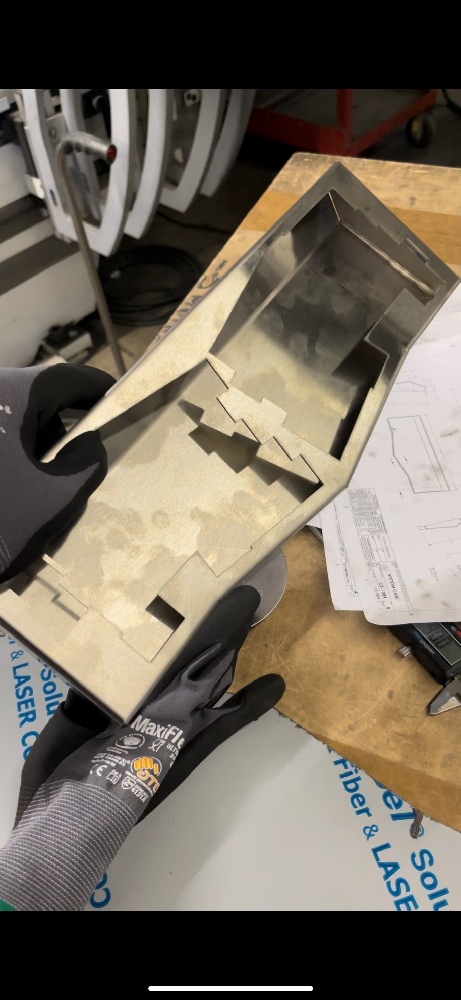

***Figure 13.*** Checking the fit for the keyboard case after bending.

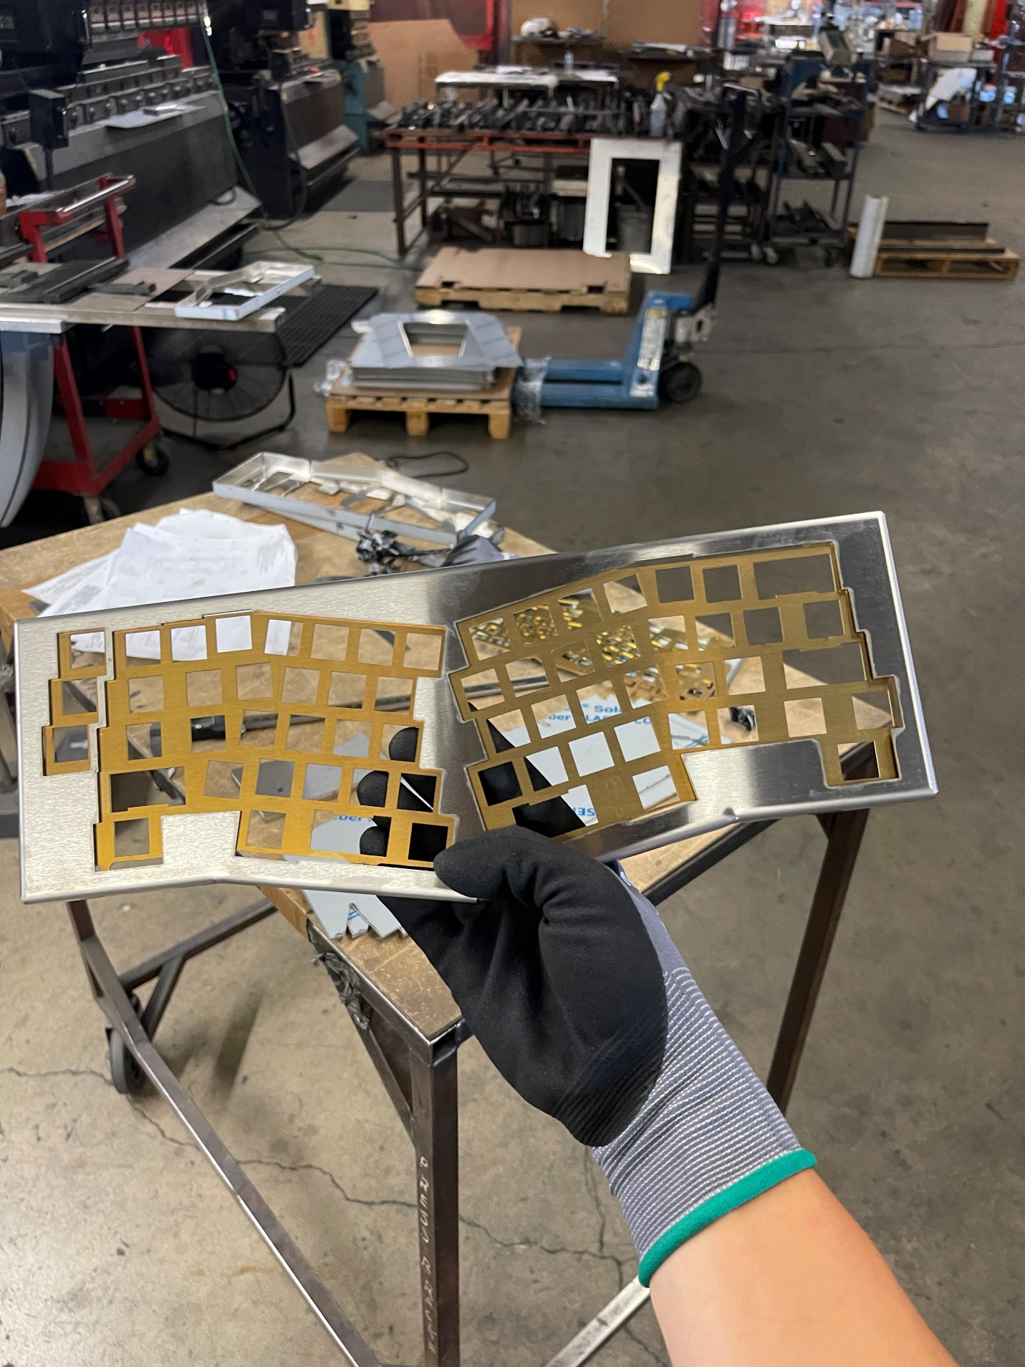***Figure 14.*** Checking fitting for CZ-2001 and CZ-2002. (see *Figure 2.* and *Figure 3.).*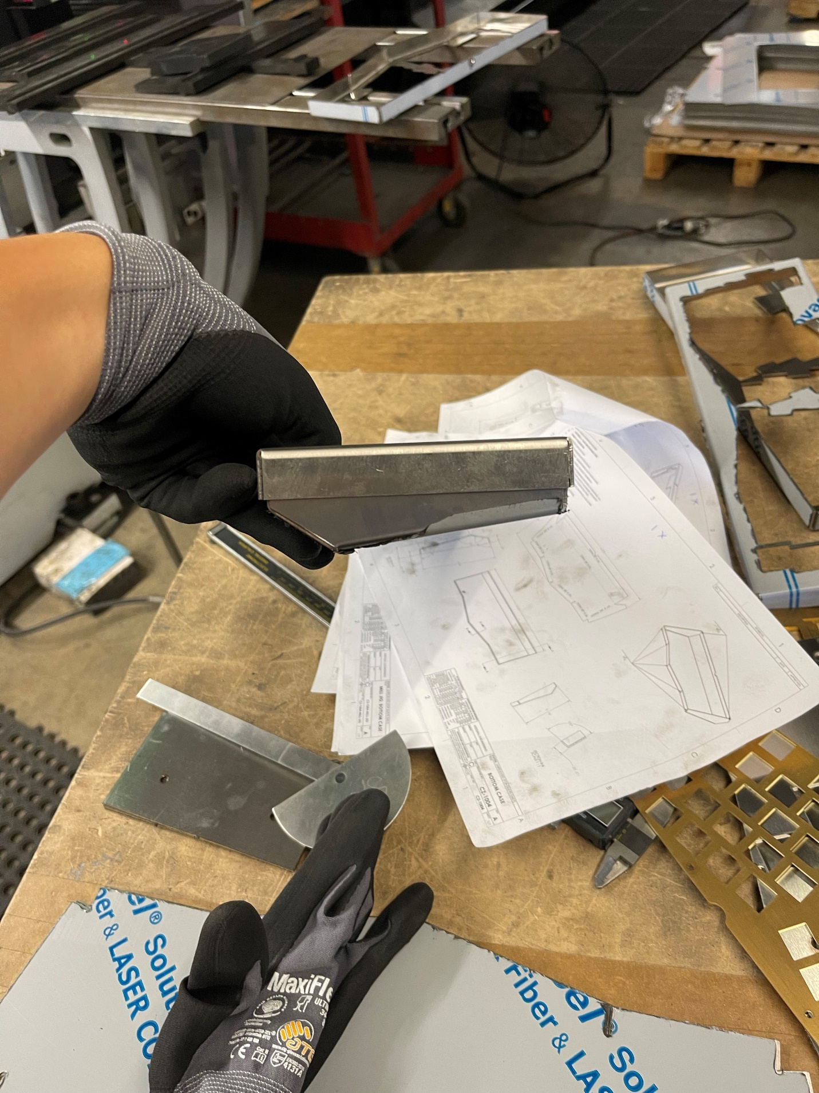***Figure 15.*** Side profile check for CZ-2000 and CZ-2001 (see *Figure 1*. and *Figure 2.*).

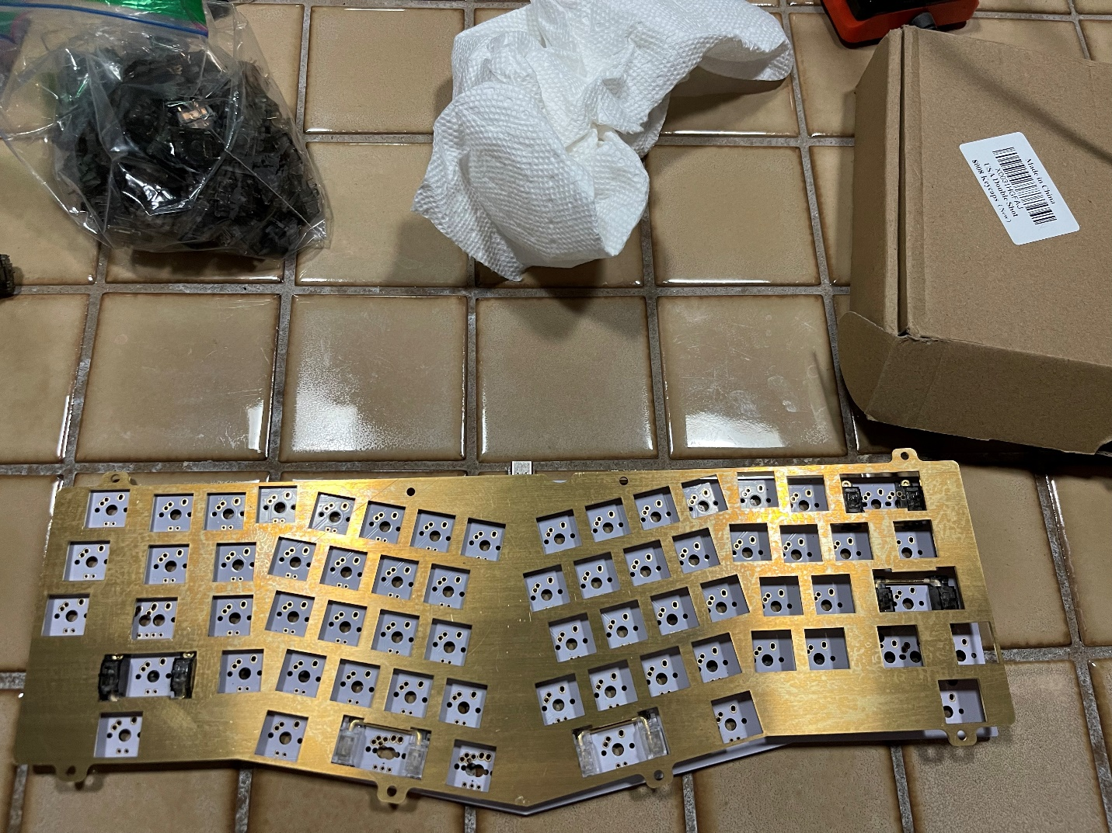

***Figure 16.*** CZ-2002 alignment with OSA Alice PCB.

.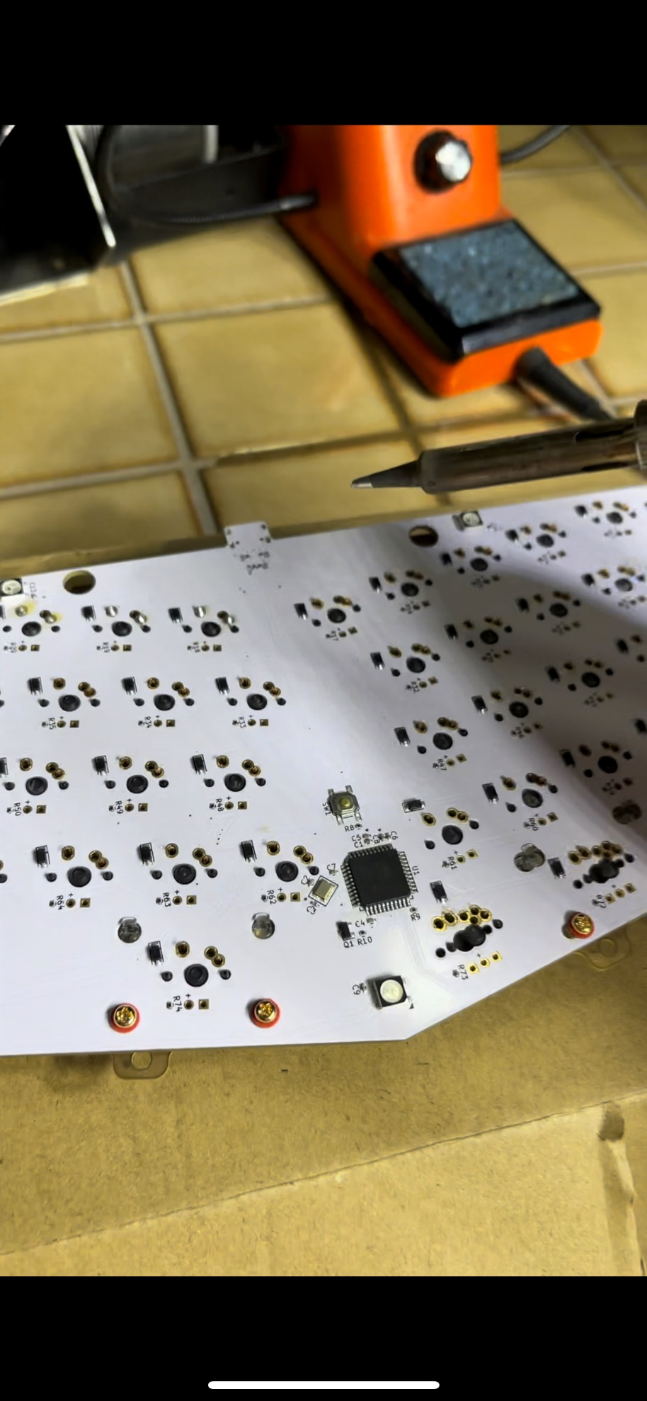

***Figure 17.*** Soldering Gateron Black Ink V2 switches onto OSA Alice PCB.

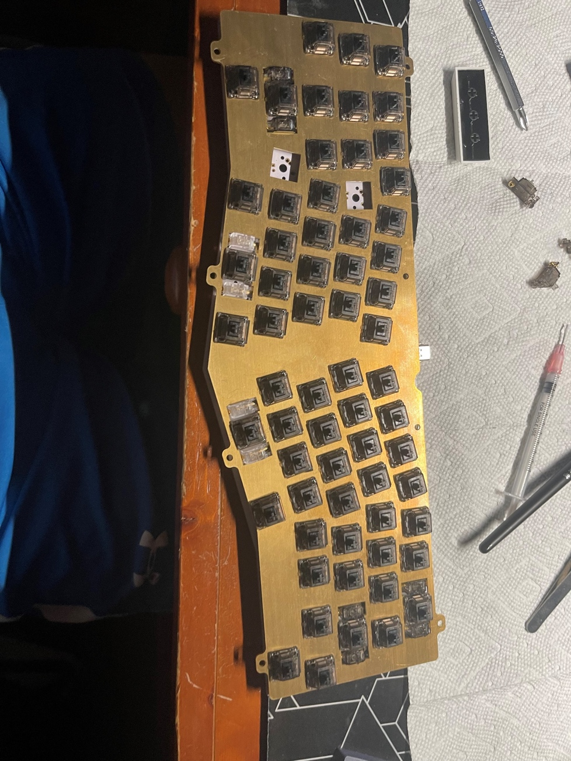

***Figure 18.*** Fitting the Gateron Black Ink V2 switches onto the keyboard plate (CZ-2002) and OSA Alice PCB.

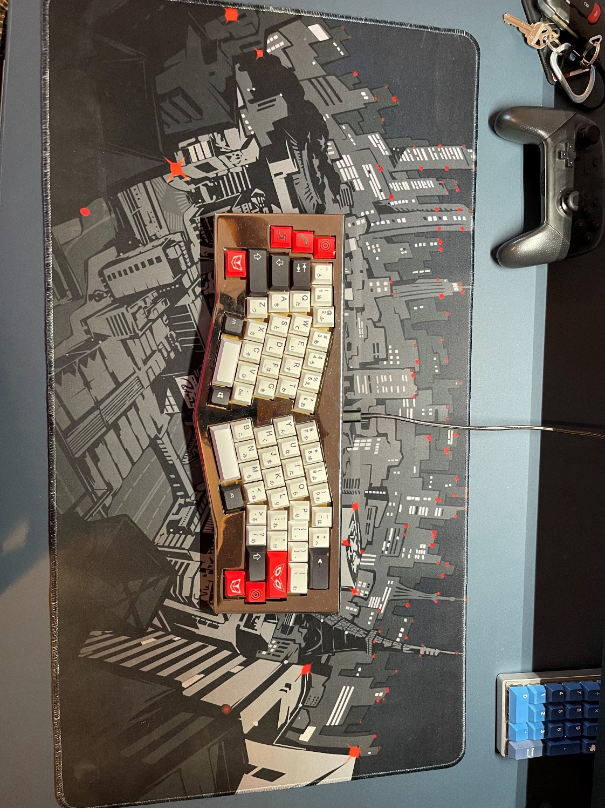

***Figure 19.*** Finished Product.

After building this keyboard, I learned more information about how to design and manufacture a product. While building this keyboard, the issues I faced was mainly based on the shape and layout of the OSA Alice PCB that was bought. The design for the keyboard caused some issues but allowed for some creativity when it came to designing the case. In this iteration of the keyboard, I decided to go with a top and bottom case covers for the keyboard that would encase the PCB and plate to create a cleaner look for the keyboard. Even though I had already built a keyboard before, this keyboard’s design was made entirely differently due to the inevitability of conforming to the shape of the PCB. I have learned from this experience building this keyboard as it helped me gain more experience in the engineering design process and manufacturing.